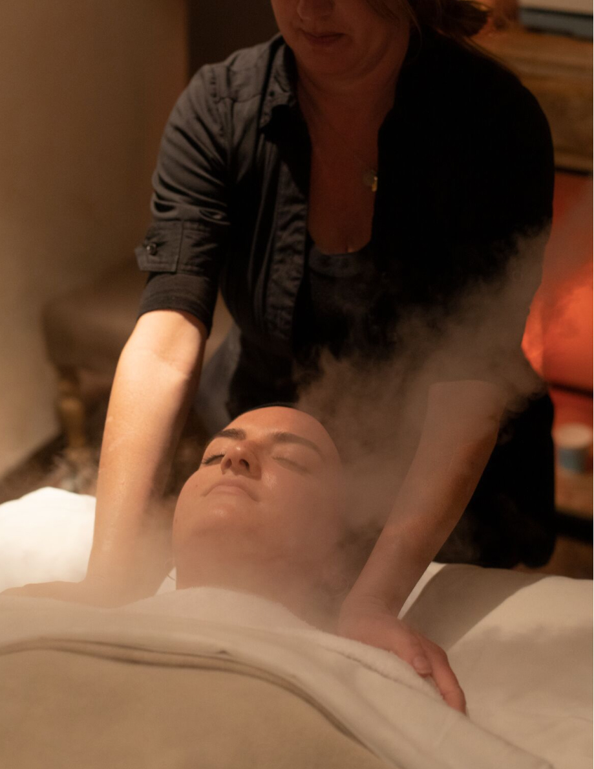

TEMPLATE
Business Plan Template for Wellness Business Owners

(Your Business Name)
Business Plan

Executive Summary

Business Overview
Provide a brief overview of your business here. Where will you be located? What type of services and treatments will you offer? This will be your elevator pitch.

Mission and Culture
What is the mission/vision of your med spa? What are your values? What’s important to you?

Target Market
Who’s your ideal customer? Why would that audience be attracted to your med spa?

Services and Offerings
What kind of services and treatments will you offer? What products will you sell? Will you offer memberships or packages? Provide a description of the services and treatments you plan to offer at your medical spa.

Market Overview and Competitive Analysis
What does your market look like? What are the demographics of your area/location?

What types of competitors are currently in your market area?

What makes your medical spa different and better than your competition? Why would someone visit your med spa versus another in your area (e.g., services differentiation, location, you and your staff are more skilled at a particular type of service, you offer unique, physician-provided cosmetic procedures, etc.)?

What are some of the challenges you might face in your market (e.g., lots of competition, difficult parking, location challenges, market demographics such as highly transient, etc.)?

Organization and Management

Staffing
What are your staffing goals?

Will you manage your various offerings, or will you have an employee who owns or is solely dedicated to each?

Will you be hiring additional medical doctors, nurse practitioners, aestheticians, or laser techs? Will you hire an office manager, operations manager, marketing team, or other operational staff? Will they be employees or independent contractors? Note: Please consult local legal counsel for advice on the best approach for your location.

How will you pay staff? Will it be a flat rate? Hourly or commission-based? Based on certification level? Will your business provide additional insurance for employees? Or will you require them to provide their own?

Will you provide staff incentives (bonuses, free services, discounts on merchandise, etc.)? What will be your measure of staff success (new clients, client retention, retail sales, etc.)?

Have you created an employee or contractor handbook that outlines your expectations for staff, including any specific requirements related to video and media releases?

Software
What business management software will you be using? We recommend getting your med spa management software set up prior to your open date so you can become proficient in managing the software and reports before you open.

How will you be trained on the software to ensure you’re using all the features to your maximum benefit and maintaining HIPAA compliance? How will you ensure your staff knows how to use the software and any equipment properly?

Bookings
How will your customers sign up for memberships and book appointments at your med spa?

Credit Card Processing
How will you manage payments for appointments, memberships, and retail products?

What kind of point-of-sale (POS) solution will you have? Will you have a mobile credit card processor?

Pricing and Retention

Pricing
What are your pricing strategies?

Will you charge cancellation fees?

Will you offer memberships? What’s your membership pricing strategy? Will you offer other benefits to membership (e.g., discount on retail)?

Will you offer flexible pricing and introductory offers? Will you offer specials or multiple services discounts? How will you promote these?

Retention
What strategies will you have in place to retain clients?

What are your retention goals?

What percentage of your clients do you want to be members?

Marketing and Sales

Brand Identity
What is your brand identity (include colors, imagery, fonts)?

Who will help you develop your branding? Will you handle and develop your marketing efforts? Or will you hire a marketing professional?

Have you confirmed your name/brand does not conflict with others in the market?

Website
Who will build and maintain your website? Who will maintain it? When will your website go live? Plan to have it up 90 days before opening.

Does your med spa software integrate with your website so clients can book appointments, sign up for memberships, and purchase retail directly from your website?

What search terms will clients use to find your med spa? Are you strategically using those terms on your website so they can find you?

Does your spa management software allow clients to book appointments with you on Google?

Social Media
What social channels will you use to promote your spa and offerings (Facebook, Instagram, TikTok, Twitter, Pinterest, etc.)?

Who will manage and monitor those channels daily (post new content, respond to questions, reply to feedback–both positive and negative)?

Will you invest in paid social media?

Advertising
Where else will you advertise (local papers, billboards, Google ads, etc.)?

PR & Influencer Marketing
Can you reach out to local press with unique ideas?

Can you partner with other businesses in your area to promote your spa?

Are there local events you can participate in to showcase your offerings?

Are there influencers in your community who can help you get the word out?

Opening Marketing Strategy
What are your launch plans? How will you initially get clients to visit your business?

Will you offer any pre-opening specials (e.g., discounted merchandise or special intro offers if the appointment booking occurs before opening)?

Equipment and Retail

Equipment Needs
List the equipment you’ll need.

Double click on the chart to input into the Excel spreadsheet

Retail Needs
Will you be selling products? Food? Water? Other branded items? Calculate your costs here.

Double click on the chart to input into the Excel spreadsheet

Financial Projections

Start-Up Costs
List the costs associated with starting your med spa.

Double click on the chart to input into the Excel spreadsheet

Ongoing Costs
Estimate your ongoing costs to run your spa.
Double click on the chart to input into the Excel spreadsheet

Funding
How will you fund your medical spa? Do you need to secure additional funding?

Key Performance Indicators and Future Vision

Success Measurements
How will you measure success? What metrics will you use to measure progress and success (e.g., memberships, revenue, appointment capacity)?

Set defined goals and make sure you measure and record progress each month.

Breakeven Analysis
What will it take to break even?
Double click on the chart to input into the Excel spreadsheet

￼

Future Vision
What is your future vision? Where do you see your med spa in one year? Three years?

Do you plan to open additional locations? Expand? Add new services?

Mindbody has everything you need to run your medical spa and achieve your goals. Visit https://www.mindbodyonline.com/business/integrative-health-software/medical-spa-software to find out more.

This plan is to be used for information purposes only and does not constitute legal, business, or tax advice. Each person should consult his or her own attorney, business advisor, or tax advisor with respect to matters referenced in this plan. Mindbody assumes no liability for actions taken in reliance upon the information contained herein. ©Mindbody 2022

