

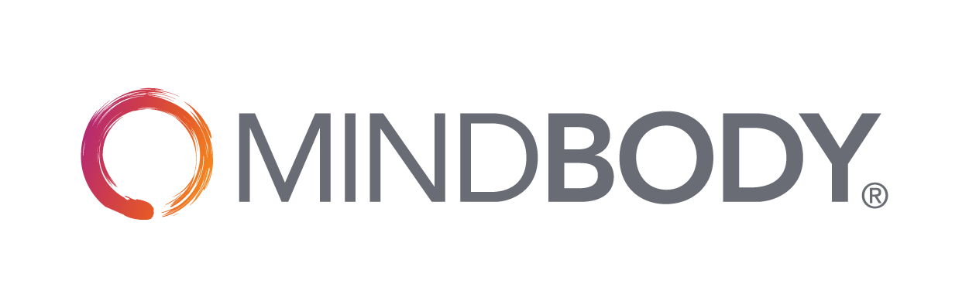

**Use this free**

**Business Plan Template**

**For Yoga Studio Owners**

**to get started on your journey**

**(Your Studio Name)**

**Business Plan**

|  |
| --- |
| **Executive Summary**  Business Overview  Provide a brief overview of your business here. Where will you be located? What type of services will you offer? This will be your “elevator pitch.” |
|  |
| Mission and Culture  What is the mission/vision of your business? What are your values? What is important to you? |
|  |
| Target Market  Who is your ideal customer? Why would that audience be attracted to your studio? |
|  |
| Services and Offerings  What kind of services will you offer? Will you offer teacher trainings? Will you offer retreats? Will you offer community classes? |
|  |
| Market Overview and Competitive  What does your market look like? What are the demographics of your area/location?  What types of competitors are currently in your market area?  What makes your studio different and better than your competition? Why would someone visit your studio versus another studio in your area (e.g., services differentiation, location, are you and your staff more skilled at a particular type of training? Will you offer something unique like fitness tracking programs, etc.)?  What are some of the challenges you might face in your market (e.g., lots of competition, difficult parking, location challenges, market demographics such as highly transient, etc.)? |
|  |

|  |
| --- |
| **Organization and Management**  Staffing  What are your staffing goals?  Will you be the manager? Or do you have plans to hire a manager? What will trigger your timing for hiring a manager?  Who will have keys to your studio?  Have you created an employee or contractor “handbook” that outlines your expectations for staff?    Will you be hiring instructors? Will they be employees or independent contractors? *Note: Please consult local legal counsel for advice on the best approach for your location.*  Will you provide staff incentives (bonuses, free classes, discounts on merchandise)?  What will be your measure of staff success (retail sales, membership conversions, new members, etc.)?  How will you pay your staff? Will it be a flat rate? Hourly?  How will you pay your instructors? Will an instructor’s pay be based on certification level?  Will your studio provide insurance for your instructors? Or will you require them to provide their own? |
|  |
| Software  What management software will you be using? *We recommend getting your business management software set up prior to your open date so you can become proficient in managing the software and reports before you open.*  How will you be trained on the software to ensure you are using all the features to your maximum benefit?  How will you ensure your staff knows how to use the software properly? |
|  |

|  |
| --- |
| Bookings  How will your customers book classes with your studio? |
|  |
| Credit Card Processing  How will you manage payments for classes and retail products?  What kind of Point of Sale (POS) solution will you have? Will you have a mobile credit card processor? |
|  |

|  |
| --- |
| **Pricing and Retention Strategies**  Pricing  What are your pricing strategies?  What is your drop-in price?  Will you charge cancellation fees?  Will you offer memberships? What is your membership pricing strategy? Will you offer other benefits to membership (e.g., mat storage, locker, discount on retail, priority class sign up)?  Will you offer flexible pricing and introductory offers? How will you promote these? |
|  |
| Client Retention  What strategies will you have in place to retain clients?  What are your retention goals?  What percentage of your clients do you want to be members? |
|  |

|  |
| --- |
| Brand Identity  **Marketing and Sales**  What is your brand identity (include colors, imagery, fonts)?  Who will help you develop your branding?  Have you confirmed your name/brand does not conflict with others in the market? |
|  |
| Website  Who will build your website? Who will maintain it? When will your website go live? *Plan to have it up 90 days before opening.*  Does your business management software integrate with your website so your clients can book classes directly from your website?  What search terms will clients use to find your business? Are you using those terms on your website so clients can find you?  Does your business management software allow clients to book classes with you on Google? |
|  |
| Social Media  Who is going to set up your social media channels?  What social channels are you going to use (Facebook, Instagram, Twitter, etc.)?  Who is going to manage and monitor those channels on a daily basis (post new content, respond to questions, reply to feedback – both positive and negative)?  Does your business management software integrate with your social channels so your clients can book classes with you directly (e.g., on Facebook and Instagram)?  Will you pay for sponsored social media posts? |
|  |

|  |
| --- |
| Advertising  Where will you advertise? Local papers? Online? Social media ads? |
|  |
| PR and Influencer Marketing  Can you reach out to local press with unique ideas?  Can you partner with other businesses in your area to promote your studio and/or events?  Are there local events you can participate in?  Are there influencers in your community that can help you get the word out? |
|  |
| Studio Opening Marketing Strategy  What are your launch plans? How will you initially get clients to come to your studio?  Will you offer any pre-opening specials (e.g., discounted memberships or special intro offers if sign up occurs before opening)? |
|  |

|  |
| --- |
| **Equipment and Retail**  Equipment Needs  List the equipment you will need  *Double click on the chart to input into the Excel spreadsheet* |
|  |

|  |
| --- |
| Retail Needs  Will you be selling gear? Food? Water? Branded items? Calculate your costs here.  *Double click on the chart to input into the Excel spreadsheet* |
|  |

|  |
| --- |
| **Financial Projections**  Start Up Costs  List the costs you will need to start up your business  *Double click on the chart to input into the Excel spreadsheet* |
|  |

|  |
| --- |
| Funding  How will you fund your business? Do you need to secure additional funding? |
|  |

|  |
| --- |
| Ongoing Costs  Estimate your ongoing costs to run your business  *Double click on the chart to input into the Excel spreadsheet* |
|  |

|  |
| --- |
| **Key Performance Indicators and Future Vision**  Success Measurements  How will you measure success? What metrics will you use to measure progress and success (e.g., memberships, revenue, class capacity)?  Set defined goals and make sure you measure and record progress each month. |
|  |
| Breakeven Analysis  What are your breakeven goals?  *Double click on the chart to input into the Excel spreadsheet* |
|  |
| Future Vision  What is your future vision for your studio? Where do you see your studio in 1 year? 3 years?  Do you plan to open additional locations? Expand? Add new services? |
|  |

MINDBODY has everything you need to run your yoga business and achieve your goals.  
Visit <https://www.mindbodyonline.com/yoga> to find out more.

*This plan is to be used for informational purposes only and does not constitute legal, business, or tax advice. Each person should consult his or her own attorney, business advisor, or tax advisor with respect to matters referenced in this plan. MINDBODY assumes no liability for actions taken in reliance upon the information contained herein. ©MINDBODY 2018*