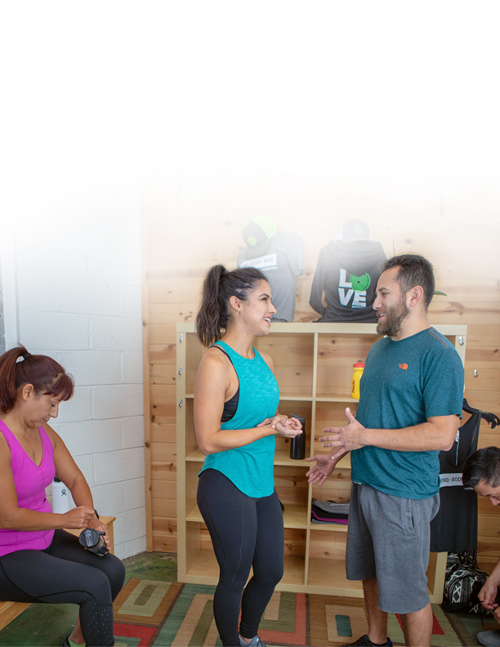
Template:
Sales Training Manual
for Your Fitness Business

(Your Business Name)
Sales Training Manual
Your Perfect Sales Pitch
Write your perfect sales pitch—keep it short and sweet.
Sales Process

How do new clients reach your business? Write out a specific sales process for each new client touch point.

For example, if someone books their first class from your website, how do you follow up with them? Is your staff alerted when a new client books a class? Does a staff member personally reach out with an email or phone call, or do you have automated emails? Who greets new visitors at your studio? What if someone visits with a family member or friend?

Think about all the different ways your new clients find you and sign up for services. Then, build a defined process and scripting for each.

Website:

Social Channels:

MINDBODY App:

Referral:

Walk-In:

Groupon or ClassPass:

Sales Collateral
Your team needs collateral to outline pricing and pick the best offer for each client.
Add links to your sales collateral here.

Sales Scripts:
Include a simple library of sales scripts for the scenarios listed above.

Staff Incentive Plan
Describe your incentive plans for staff—make them simple and straightforward. Be sure to outline any differences in incentives for front desk staff versus instructors or trainers. Include performance expectations, required sales quotas, and implications if performance expectations aren’t met.

Sales Rebuttals

Your staff will hear common reasons why new visitors can’t commit, or why members won’t recommit. Outline them here and draft answers/rebuttals for each one.

For example:

I don’t want to commit to just one fitness studio.

I might be traveling a lot in the coming months.

MINDBODY has everything you need to run your fitness business and achieve your goals.
Visit https://www.mindbodyonline.com/fitness to find out more.

This template is to be used for informational purposes only and does not constitute legal, business, or tax advice. Each person should consult his or her own attorney, business advisor, or tax advisor with respect to matters referenced in this template. MINDBODY assumes no liability for actions taken in reliance upon the information contained herein. ©MINDBODY 2018

