­­

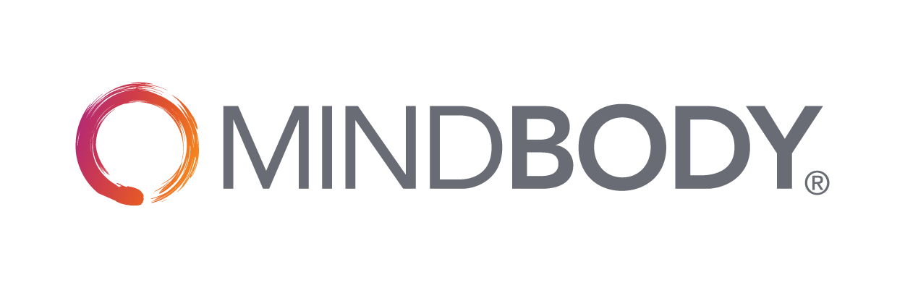

**Template:**

**How to Create a Marketing Plan and Budget for Your Business**

**(Your Business Name)**

**Marketing Plan**

|  |
| --- |
| **Marketing Goals**  What are your three most important business goals for the next six months to a year? Write down your S.M.A.R.T (specific, measurable, attainable, relevant, time-bound) goals below. For example: “Sell an average of 60 Introductory Offers each month by the end of the first quarter.” |
| 1.  2.  3. |
| Business Summary: Who are you?  Defining who you are as a business helps you determine your target customer. |
| Where are you located?  What service(s) do you provide?  How do you stand out from your local competition?  How can you continue to improve? |
| Target Market: Who’s your ideal customer?  Defining your target customer is key to evaluating your offerings and what marketing methods you should use, ranging from print and online ads to pop-up events and open houses. |
| How old are they?    Where do they live?    Where do they work?  What do they value?  What problems do they have?  How can you help fix these problems? |
| Strategy: How will you reach your target customer?  Now it’s time to outline the ways you’ll attract, convert, and retain customers  at each point of their customer journey—from Awareness to Advocacy.  Awareness: How will you help new customers find your business? |
| Which (if any) traditional advertising outlets will you use?  Will you host pop-up events? Open-houses? How will you encourage customers to attend (e.g. discounts or raffles)?  Is your website live? If not, who will build it? Does your business management software integrate so clients can easily book classes and services?  Are your profiles set-up and optimized on Yelp, Bing, and Google?  Do you plan to run Pay-Per-Click (PPC) ads?  What social media platforms will you use?  Are your social media profiles fully optimized?  Do you have a staff member who’s responsible for posting and engaging regularly?  Do you plan to run social media ads? What will you promote? |
| Action: How will you convert prospects into customers? |
| What’s your introductory offer? How will you promote it?  If you’re a class-based business, will you use Dynamic Pricing to fill your classes? What are your minimum and maximum prices? |

|  |
| --- |
| Loyalty: How will you keep customers coming back? |
| How will you check in with customers during their introductory offer?  How will you stay in touch with existing customers?  How will you get existing customers to return when you haven’t seen them in a while? |
| Advocacy: How will you retain customers and encourage them to spread the word? |
| How will you encourage happy customers to write reviews (and promote the ones you  receive)?  Do you have a referral program to reward loyal customers?  How will you stay connected with your current customers? Events? Social media contests? Workshops? |

|  |
| --- |
| **Budget**  What’s your monthly marketing budget? How much will be allocated to each strategic effort?  Double click on the chart, below, to input into the Excel spreadsheet |
| ­ |

­

|  |
| --- |
| **Key Performance Indicators (KPIs)**  KPIs  Are you seeing results from your marketing? Your KPIs will help you evaluate your efforts and see if you’re reaching your goals.  Remember: Marketing takes time. While you’ll want to keep tabs on your KPIs every month, you’ll really only need to re-evaluate every six months.  Double click on the chart to input into the Excel spreadsheet |
| New Clients: This number should grow every month. If not, you’ll likely want to increase marketing efforts and spend related to Awareness.  Intro Offers Sold: Not where you want to be? It might be time to reevaluate your introductory offer duration and price. Here are some [tips for successful intro offers in the MINDBODY app](https://support.mindbodyonline.com/s/article/215861297-Tips-for-successful-intro-offers-in-the-MINDBODY-app?language=en_US).  Referral Types: What are the top three ways customers hear about your business? If word-of-mouth referrals are two to three times higher than other forms, consider revisiting your marketing mix and investing more in your marketing budget. |

MINDBODY has everything you need to run your fitness business and achieve your goals.  
Visit <https://www.mindbodyonline.com/fitness> to find out more.

This plan is to be used for informational purposes only and does not constitute legal, business, or tax advice. Each person should consult his or her own attorney, business advisor, or tax advisor with respect to matters referenced in this plan. MINDBODY assumes no liability for actions taken in reliance upon the information contained herein. ©MINDBODY 2018