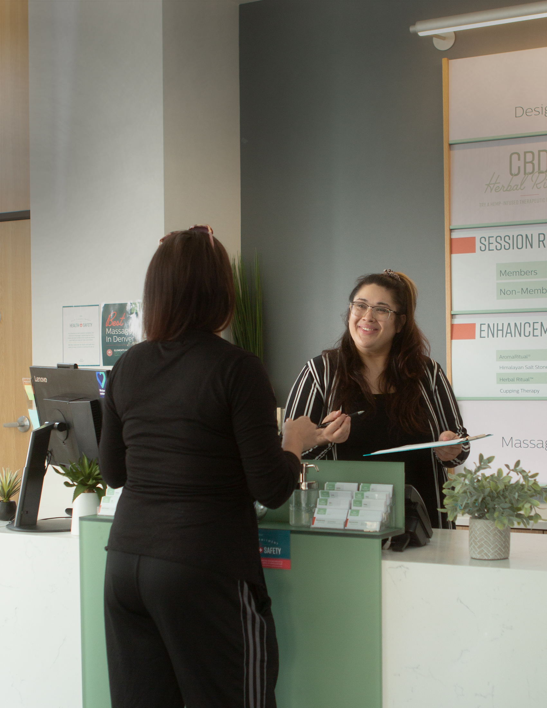


TEMPLATE
First Visit Report Workbook
for Salons, Spas, and
Wellness Businesses

(Your Business Name)
First Visit Report Workbook

Your business welcomes new faces every week—especially if you take advantage of ClassPass. When new clients walk through your doors, they’re welcomed by your front desk team, introduced to their provider, and given an exceptional experience. They leave their appointment relaxed and filled with confidence.

You’ve created a space where clients come to feel great. Now what?

Staying connected with multiple touchpoints (phone call, text, email, or in-person conversation) is necessary for a buyer—or in this case, a new client—to commit to your business. If your staff isn’t following up with every first-time guest, you’re missing out on key opportunities to grow your client list and your revenue.

Ready to turn those first time visitors into loyal regulars? This workbook is designed to do just that.

But first, review your First Visit report

How well are you retaining first-time clients now? Let’s look at the numbers.

If you’re a Mindbody customer:
- Log into the software
- Click Reports in the upper right corner
- Click Client > Visits & Retention > First Visit (or search First Visit)
- Select dates (Choose dates at least 2-3 months in the past)
- Choose the Service Category you want to analyse (start with your biggest category)
- Click Tag New to see the unique number of first-time clients during this time frame
- Record the number of tagged clients

- Change the end date to be the end of the most recent month
- Under Filters, check:
  - Show tagged clients only
  - Only show clients with no visits after the first visit
  - Click Go!
  - Go to the bottom left to find the number of those who didn’t return

- Divide the two numbers to get a %

Consider your current follow-up process

How do you keep track of first-time clients (aka new leads)? Do you run reports and use sticky notes, a spreadsheet, etc.? Jot down your system(s) below.

How do you check in with clients after their first appointment (e.g., text, email, phone call, in-person conversation)? Write down all touchpoints below.

If you use text or email, how do you communicate in a way that’s true to your brand? Add (or draft) your follow-up text(s) and/or email(s) below. We've included examples.

Follow-up text(s):

How to write a great follow-up text:
- Personalise the message
- Use your brand voice (which may or may not include the use of emojis)
- Say thanks
- Include a question to prompt a response

Example: Hi [client name] 👋 Thank you so much for visiting [business name] today! How was your first [service type]?

Example: We hope you had a great first [service type] at [business name], [client name]! Thanks so much for coming in! When can we get your next one booked out?

Example: It was so great to meet you today, [client name]! Are you interested in our new client special? It includes [new client special details] for [price].

Follow-up email(s)

How to write a great follow-up email:
- Personalise the message
- Use your brand voice
- Link out to your website for more information
- Add a CTA

Example: Thanks so much for coming to [business name], [client]! We hope you’re feeling refreshed and confident—that’s what a [service] always does for us!

To make the most of your [service], remember to:
- [Post-appointment tip]
- [Post-appointment tip]
- [Post-appointment tip]

For your next appointment, don’t miss out on our new client special! It includes [details of new client special] for [price].
CTA: Buy it now!

Optimise your approach

How much time and effort does it currently take to keep tabs on new clients? Do you use sticky notes and spreadsheets? Do you have a staff member dedicated to keeping track of your sales pipeline? How many hours are spent each week/month managing this process (if at all)? Calculate below.

Consider how much time your follow-up touchpoints take. Do you have a staff member dedicated to reaching out via text/email/phone call? How many hours are spent on follow-ups each week/month (if at all)? How much does that cost you in payroll? Calculate below.

What if you could save time, money, and hassle, while also improving first-time visitor retention? Automation can help. Here’s how:

- With Lead Management, it’s simple to manage new leads with the integrated dashboard. Get access to insights about your sales process to identify—and fix—any gaps you might have.

- With Messenger^{[AI]}, an AI receptionist, every prospective customer is followed up with after their appointment via text—automatically. It books appointments, answers questions, and sells packages and memberships, too. That way, your staff stays focused on in-person interactions while Messenger^{[AI]} handles the rest.

- With Marketing Suite, you can send additional email follow-ups to ensure your new client feels well cared for. Pro tip: Offer post-treatment tips, relevant product recommendations, and make it easy to click through and rebook. Marketing Suite and Messenger^{[AI]} work together to create a seamless experience for all. No new client left behind!

Mindbody has everything you need to make client communication easier and more effective, so you can focus on doing what you love. Head to https://www.mindbodyonline.com/en-au/business-welcome to find out more.

This document is to be used for informational purposes only and does not constitute legal, business, or tax advice. Each person should consult his or her own attorney, business advisor, or tax advisor with respect to matters referenced in this template. Mindbody assumes no liability for actions taken in reliance upon the information contained herein. ©Mindbody 2022

